Kent Rugby Young Coach Certificate
Application Form

Before completing your application
Please read the application form carefully and complete all of the required information. The following are mandatory prerequisites for all applicants:
- You must be aged between 14 – 18
- You will need to have an appropriate coaching placement arranged with own or local club
- You must be able to attend ALL of the sessions and meet ALL of the required coaching hours. There will be no opportunities to “catch up” and failure to meet all of the programme requirements will result in withdrawal from the certificate.
Programme overview:
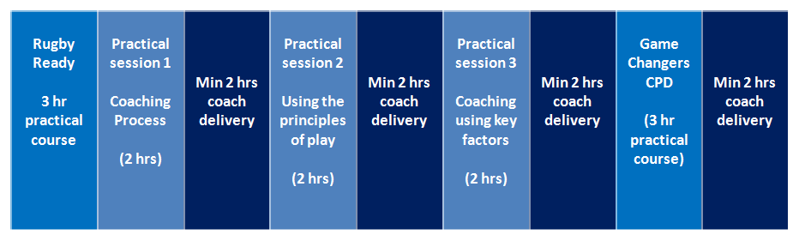
Participants will also be required to complete the following online learning modules Prior to the commencement of the course evidence will be required at session 1:
- World Rugby online “Rugby Ready” course
- World Rugby online Fundamentals of Coaching course
- RFU Headcase online course

Programme dates, times and venue:
Monday 9th March, 7pm to 10pm- Rugby Ready
Monday 23rd March, 7pm to 9pm- Coaching Process
Monday 30th April, 7pm to 9pm- Using the Principles of Play
Monday 6th April, 7pm to 10pm- Game Changers
Monday 20th April, 7pm to 10pm- Coaching using Key Factors and Presentation of Certificate

ALL sessions will take place at Medway RFC, Priestfields, Rochester ME1 3AD

How to register for online courses
You will be required to complete three online courses by the end of the programme and provide certificates of completion as evidence. If you wish, you may undertake these prior to the programme starting.
If you haven’t already done so, you will need to register with England Rugby and World Rugby in order to complete the online courses which are prerequisites for the Young Coach Certificate
Register with RFU
Register with World Rugby
How to complete online courses
Once registered, you must complete the following online courses and provide evidence of completion (certificates) with your application.
Complete RFU Headcase
Complete World Rugby Introduction to Coaching
Complete Rugby Ready Online

Application for the Kent Rugby
Young Coach Certificate

Personal Details
Full Name:
Date of Birth:
RFU ID (If known):

Parent/Carer details (if applicant is under 18)
Parent/Carer Name(s):
Contact Tel Nos:

Club / coaching placement details:
Name of Club:
Name of Club Coaching Coordinator (CCC):
Name of Head Coach that applicant will be assisting:
Age group that applicant will be assisting:

Personal Statement:
Please tell us about yourself, your involvement in rugby to date and why you would like to complete this certificate:

