KCRFU 43rd Mini Festival
Sunday 29th March 2026 Welcome Pack

Dear Age Group Contact

We are delighted to welcome you to the 43rd Kent County RFU Mini Festival. This year, Aylesford Bulls RFC is proud to Co- host the Under 7’s age group. We look forward to welcoming your players, coaches, referees, first aiders, and supporters for a fantastic day of rugby.

This Welcome Pack contains all the key information you will need for the day. Please ensure it is shared with all visiting coaches, parents, and volunteers.

Important Contacts

 | Name | Contact number | Email address
Chairperson | Tony Merlini | 07916314529 | tony.merlini@me,com
Chair for minis | Mark Burrows | 0798516874
Safeguarding | Jayne  Ashdown-Denney | 07842962825 | jayneashdowndenney@gmail.com
Event Organiser | Jayne & Mark | As above | As above
KCRFU Mini Chairperson | Dawn Waters | 07931511424 | mini-rugby@kent-rugby.org
KCRFU Mini Vice Chair | Jamie Callaway | 07753451021 | mini-rugby-vicechair@kent-rugby.org

Your first contact for the day should be the festival organiser as they will know the information and requirements for their venue. Please go through your age group contact in all correspondence unless it is an emergency.

Club address
Please note all parking and pitch are situated at Ferryfield Recreation Ground, Station Hall, Aylesford, Kent. ME20 7JL

Important Timings on the day

Car Park | 08:30am-2:00pm
Registration | 08.45 am - 09.30 am
Referees Briefing | 09.30 am
All players, spectators and visitors on site by | 09.30 am
First Matches Kick off | 10.00am
Festival Ends | 13.00pm(approximately)

Parking

The car park will open at 08:30. Parking is limited, so please encourage car sharing where possible.

Blue Badge bays will be available — please contact us in advance so we can reserve space.

Additional parking is available on surrounding roads, including:

RBL VILLAGE HALL ONLY IF POOR WEATHER

Please Park respectfully and avoid blocking driveways or restricting access for residents.

A site map will be provided showing parking areas and pedestrian routes.

Gate/Entry fees

As per Kent County RFU guidelines for all the minis Kent events, entry to all grounds will be £2.50 per adult (children free entry). Cash is preferred to facilitate swift entry to the site although there will be a limited number of card machines. Wristbands will be issued as proof of payment.

This fee is separate to the counties entry fee per team as the KCRFU Mini Festival is a self-funding festival so all team’s entrance fees paid go towards the counties running costs i.e. first aid, medals, memorabilia, balls etc. Whereas the entrance fee on the day goes to the running costs for the hosts i.e. toilets, pitch maintenance, parking costs etc.

Registration

All teams must register on arrival using the official KCRFU Team Sheet & Photography Consent Form.
The registration desk will be located at:

IN FERRYFIELD RECREATION GROUND
Please ensure:
- RFU numbers and dates of birth are completed.
- All players are registered on GMS.
- Squad sizes comply with the festival maximums:

If you wish to forward your registration forms to us prior to the event, please email them to the festival organiser jayneashdowndenney@gmail.com. Unfortunately, we will not be able to cater for any additional players over the team size with regards to medals etc so please ensure you stick to the maximum team size as below.

Age Group | Players on Pitch | Max. Squad size including subs
Under 7 | 4 players | 6 players
Under 8 | 6 players | 10 players
Under 9 | 7 players | 12 players
Under 10 | 8 players | 14 players
Under 11 | 9 players | 16 players

All participating players must be RFU registered on the RFU’s registration platform (GMS).

To allow us at Kent County RFU to plan we will be completing a player audit in the forthcoming weeks of which all registration forms will assist us in completing.

Team selection
This is a mixed-ability, non-competitive festival.
- No scores are to be recorded.
- Please ensure teams are balanced and inclusive.
- The focus is on enjoyment, development, and positive rugby experiences. Festival Rules

Regulation 15 Age Grade Rules will apply to all rugby games. The festival rules can be found in the mini section of the KCRFU Website Kent County RFU » Mini

Players, coaches, and spectators are required to observe the appropriate Codes of Conduct.

Presentations

There will be no central presentation at the end of the festival.
Each club is encouraged to hold its own awards with players. Every participant will receive a medal and a piece of festival memorabilia.

Programme and Match Schedule

All schedules and pool drawers will be released on the Kent County Website on the afternoon of Friday 27th March .

Pitch marshals will have hard copies of playing schedules for reference. Please try to keep to the match playing schedule – right pitch – right time and help us to ensure the day is full of free-flowing rugby games with as few hold ups as possible

Pitch marshals will be on hand to assist.

No matches will be rescheduled.

First Aid

Each team must bring:

- A first aid kit
- A qualified first aider

will be a mobile unit and the first aider will be walking- the pitches at all times Kent County RFU will provide additional festival level first aid cover from Pulse South Coast,this

Emergencies
The festival control point is the central registration. Please report:
- Injuries
- Lost children
- Pitch issues
- Safeguarding concerns
- General problems to the control team immediately.
Any lost children must be taken to or reported to the central registration/control tent.

Referees

Each team must provide a referee for half of each match (usually a coach).

All referees must attend the briefing at 09:30 at the (Insert clear location).

Refreshments
All refreshment will be available from our mobile BBQ the will be situated at the entrance to the club site from Ferryfield but clearly signposted

Toilets
All toilets are within the changing room of the clubhouse
.

Photography

The organisers recognize the need to ensure the safety and well-being of all the youngsters playing in the festival. As a part of this commitment the taking of photographs will be permitted only within the guidelines laid down by Kent County RFU. Accredited Press photographers may also be present.

Dogs

- Dogs must be kept on a lead at all times.
- Owners must clean up immediately.
- Dogs are not permitted inside the clubhouse or food preparation areas.
- Dogs must not enter playing areas.

Tents and Gazebos

You’re more than welcome to bring tents and gazebos, please ensure that they are placed in the designated areas on the map below only at least 5m away from pitch boundaries and placed in the area outlined on the site map. It is imperative that you secure your gazebos with pegs. The weather can change quickly and there is limited shelter around the pitches, for the safety of all visitors we don’t want tents flying around.

Rubbish

Please take all rubbish to the bins provided. We appreciate your help in keeping the club tidy.

Club Values and Behaviour

Kent County RFU and its festival hosts promote and encourage the core rugby values of Teamwork, Respect, Enjoyment, Discipline and Sportsmanship.

We expect all coaches, players, and supporters to uphold these throughout the festival.

Finally, we hope you, your players and families have a great day and enjoy the event.

Best regards

Aylesford Bulls RFC

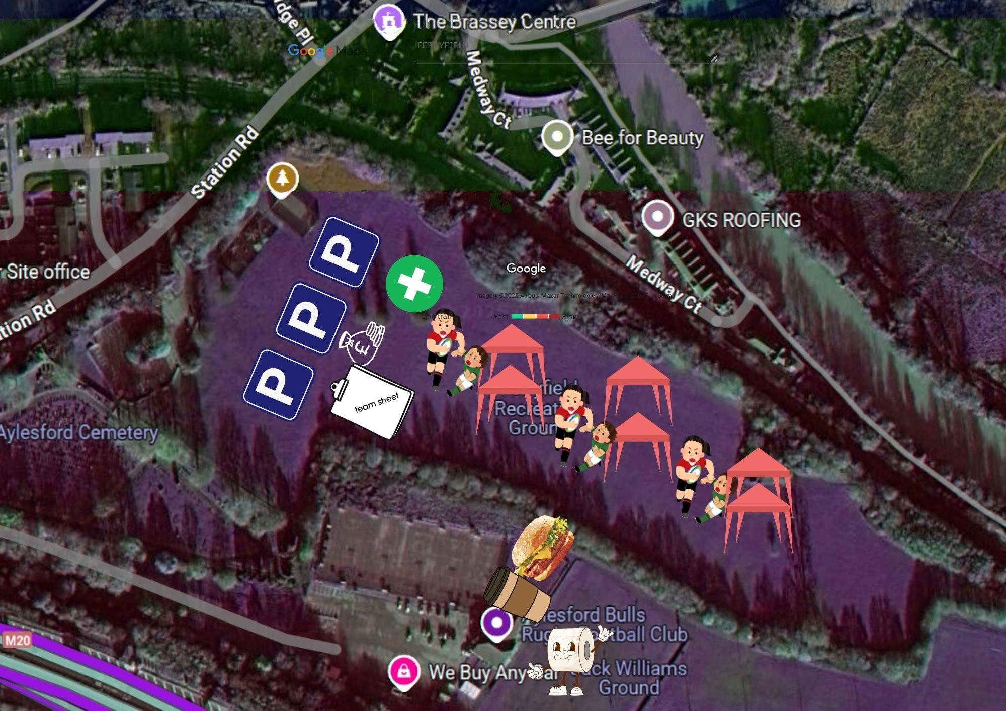

ALL PARKING WILL BE AT FERRYFIELD
RECREATION GROUND HALL ROAD AYLESFORD.

ALL PITCH ARE ALSO WITHIN FERRYFIELD RECREATION GROUND

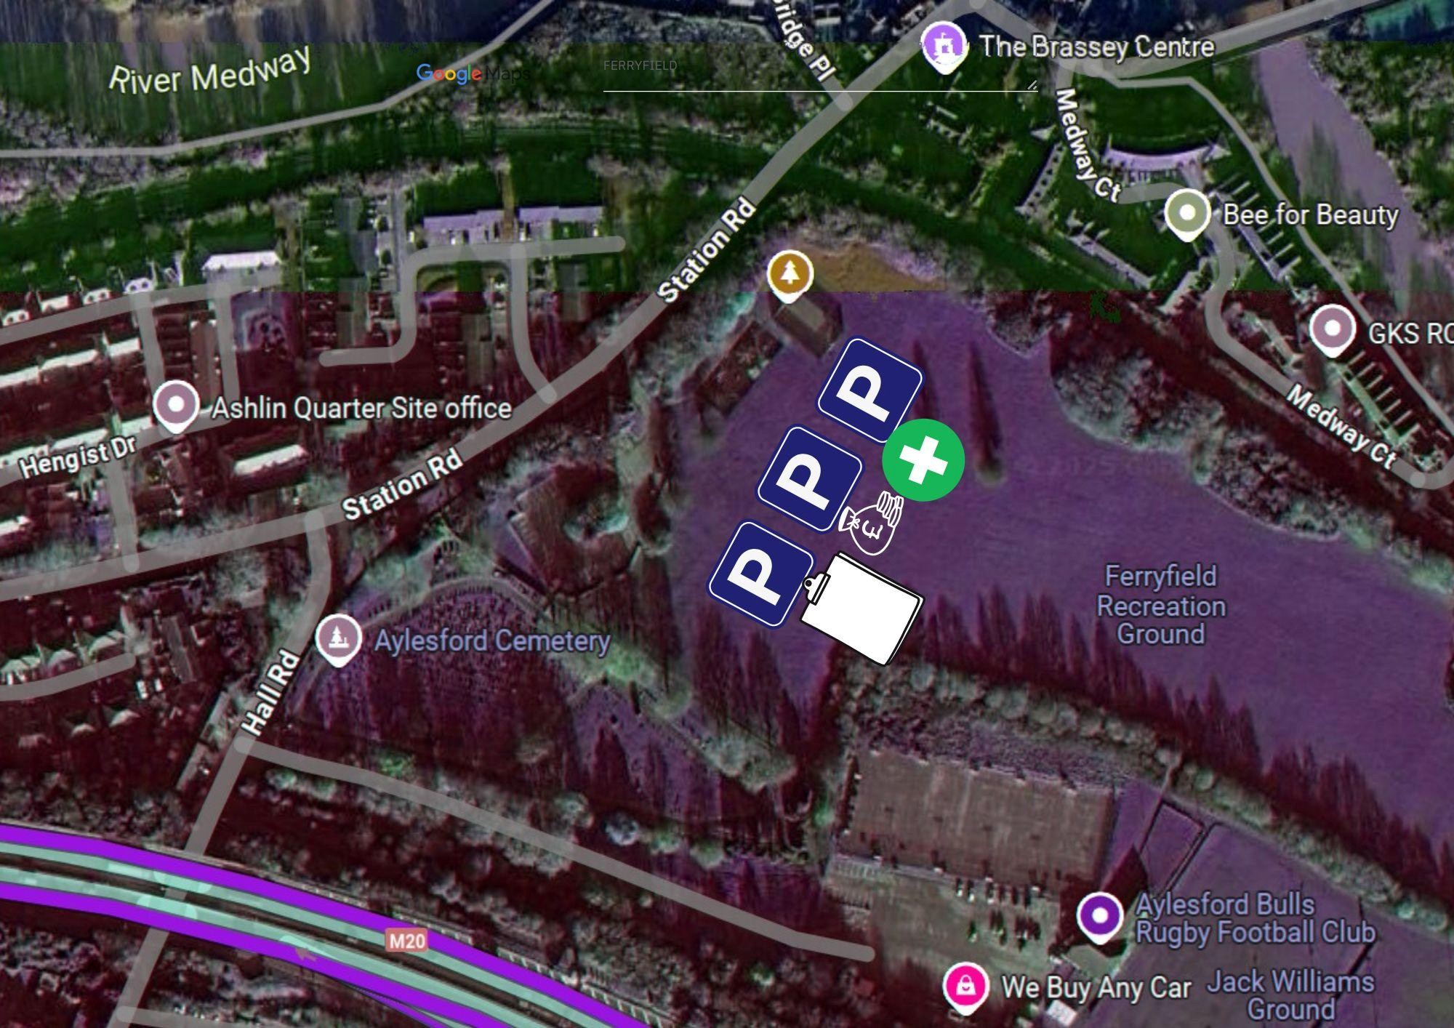

Aylesford Bulls RFC
Kent Mini 43rd Festival
Team sheet & Photography Consent Form
Sunday 29th March 2026

Club and Team name
(if more than 1 team entered please enter a sheet for each team)
Age Group
Head Coach name
Contact number
Referee
Team first aider name

 | Name of Player | Date of Birth | RFU  Registration Number | Parent/ Guardian  Consent to photography
1
2
3
4
5
6
7
8
9
10
11
12
By completing this team sheet, you agree to the festival terms and conditions, including: ● All players must be RFU affiliated and registered to their club.
Aylesford Bulls RFC
Kent Mini 43rd Festival
Team sheet & Photography Consent Form
Sunday 29th March 2026
- Each team must provide a referee and first aider.
- Any dispensations or out-of-age-band approvals must be declared in advance.

Kent County RFU contact list

Kent County RFU Minis Contact
Dawn Waters | 07931511424 | mini-rugby@kent-rugby.org
Jamie Callaway | 07753451021 | mini-rugby-vicechair@kent-rugby.org

Kent County RFU Safeguarding
Dawn Stanford | safeguarding@kent-rugby.org
Kent County RFU Disciplinary
Jayne Ashdown Denny | age-grade-discipline@kent-rugby.org

Kent County RFU Rugby Safe
Peter Thompson |  | rugbysafe@kent-rugby.org

