Dear Age Group Contact,

We are delighted to welcome you to the 43rd Kent County RFU Mini Festival. This year, TJs is proud to Co- host the Under 9’s age group. We look forward to welcoming your players, coaches, referees, first aiders, and supporters for a fantastic day of rugby.

This Welcome Pack contains all the key information you will need for the day. Please ensure it is shared with all visiting coaches, parents, and volunteers.

Important Contacts

 | Name | Contact number | Email address
TJs Festival Coordinator | Vicky Court | 07879 835863 | minis@tjrfc.co.uk
TJs Minis Chairman | Dave Turner | 07450 576769 | minis@tjrfc.co.uk
TJs Head of Rugby | Darren Reeves | 07834 225584 | dreevesrugby@gmail.com
KCRFU Mini Chairperson | Dawn Waters | 07931511424 | mini-rugby@kent-rugby.org
KCRFU Mini Vice Chair | Jamie Callaway | 07753451021 | mini-rugby-vicechair@kent-rugby.org

Your first contact for the day should be the festival organiser as they will know the information and requirements for their venue. Please go through your age group contact in all correspondence unless it is an emergency.

Club address

Tonbridge Juddians RFC, The Slade, Tonbridge, Kent, TN9 1HR | What 3 Words: ///noise.jokes.bets

Important Timings on the day
Registration | 08.45 am - 09.30 am
Referees Briefing | 09.30 am
All players, spectators and visitors on site by | 09.30 am
First Matches Kick off | 10.00am
Festival Ends | 13.00pm(approximately)
Parking

Please be aware that Bank Street is subject to a road closure due to Southern Water roadworks, in place until 30th March. This may affect your route when leaving the club via car or the Upper Castle Car Park after the festival.

Parking at TJs is limited, so please leave plenty of time to arrive at the club. Below are some local public car parks - be warned that parking charges do apply on Sundays. Blue Badge bays will be available at the club, so please contact us no later than Friday, 27 March to reserve a space.

Car Park | Postcode | Walk | What 3 Words
Upper Castle Car Park | TN9 1BL | 4 min | ///surely.player.sofa
Bradford Street | TN9 1DU | 9 min | ///wash.resist.deals
Botany Car Park (Waitrose) | TN9 1RG | 10 min | ///envy.fear.speaks
Sovereign Way East | TN9 1RG | 12 min | ///fuels.beyond.intervals
Sovereign Way Mid | TN9 1RG | 10 min | ///tolls.next.scared
Sovereign Way North | TN9 1RS | 12 min | ///crew.reveal.pushy
Angel West (Sainsbury's) | TN9 1SF | 10 min | ///leader.racing.focus
Ave du Puy / Vale Road | TN9 1QH | 12 min | ///maker.plant.wisely

Gate/Entry fees

As per Kent County RFU guidelines for all the minis Kent events, entry to all grounds will be £2.50 per adult (children free entry). Cash is preferred to facilitate swift entry to the site although there will be a limited number of card machines. Wristbands will be issued as proof of payment.

This fee is separate to the county’s entry fee per team as the KCRFU Mini Festival is a self-funding festival so all team’s entrance fees paid go towards the counties running costs i.e. first aid, medals, memorabilia, balls etc. Whereas the entrance fee on the day goes to the running costs for the hosts i.e. toilets, pitch maintenance, parking costs etc.

Registration

All teams must register on arrival using the official KCRFU Team Sheet & Photography Consent Form. Head to the registration gazebo (see pitch map below) when you arrive to sign in and collect your medals. If you wish to forward your registration forms to us prior to the event to make things easier and faster for everyone, please email them to Vicky at minis@tjrfc.co.uk by end of day on Friday, 27th March.

Please ensure:

- RFU numbers and dates of birth are completed.
- All players are registered on GMS.
- Squad sizes comply with the festival maximums.
- All players have gum shields. There will be a few onsite available for purchase if needed.

Unfortunately, we will not be able to cater for any additional players over the team size with regards to medals etc., so please ensure you stick to the maximum team size as below.

Age Group | Players on Pitch | Max. Squad size including subs
Under 7 | 4 players | 6 players
Under 8 | 6 players | 10 players
Under 9 | 7 players | 12 players
Under 10 | 8 players | 14 players
Under 11 | 9 players | 16 players

All participating players must be RFU registered on the RFU’s registration platform (GMS).

To allow us at Kent County RFU to plan we will be completing a player audit in the forthcoming weeks of which all registration forms will assist us in completing.

Team selection
This is a mixed-ability, non-competitive festival.
- No scores are to be recorded.
- Please ensure teams are balanced and inclusive.
- The focus is on enjoyment, development, and positive rugby experiences.
Festival Rules

Regulation 15 Age Grade Rules will apply to all rugby games. The festival rules can be found in the mini section of the KCRFU Website Kent County RFU » Mini

Players, coaches, and spectators are required to observe the appropriate Codes of Conduct.

Presentations

There will be no central presentation at the end of the festival.

Each club is encouraged to hold its own awards with players. Every participant will receive a medal and a piece of festival memorabilia.

Programme and Match Schedule

The pool draws and full playing schedule will be published on the Kent County website on the afternoon of Friday 27th March: www.kentrugby.org

Pitch marshals will have hard copies of playing schedules for reference. Please try to keep to the match playing schedule – right pitch – right time and help us to ensure the day is full of free-flowing rugby games with as few hold ups as possible

Pitch marshals will be on hand to assist.

No matches will be rescheduled.

First Aid

Each team should bring their own first aid kit and have a trained first aider with them. Kent RFU are also providing additional first aid cover through Pulse South Coast, based near the registration gazebo throughout the day.
The registration gazebo is your go-to for anything on the day: emergencies, pitch issues, or anything you're not sure about. Any lost children should be taken to or reported to the registration/control gazebo as soon as possible.

Emergencies
The festival control point is the central registration.
Please report:
- Injuries
- Lost children
- Pitch issues
- Safeguarding concerns
- General problems
to the control team immediately.
Any lost children must be taken to or reported to the central registration/control tent.

Referees

Each team must provide a referee for half of each match (usually a coach).

All referees must attend the briefing at 09:30 at the registration gazebo.

Refreshments

Hot and cold drinks and breakfast options are available in the clubhouse from 7.30 am, so arrive early, snag a close parking spot, and get some food and coffee!

Outside there'll also be hot food, a pizza van, hot drinks, a tuck shop, and horsebox bar for the duration of the festival. Food and drink will continue in the clubhouse throughout the festival as well.

Toilets

Toilets and disabled facilities are in the main clubhouse entrance via ramp, with additional portaloos on the middle field.

Photography

The organisers recognize the need to ensure the safety and well-being of all the youngsters playing in the festival. As a part of this commitment the taking of photographs will be permitted only within the guidelines laid down by Kent County RFU. Accredited Press photographers may also be present.

Dogs

Four-legged supporters are welcome at TJs! Please keep dogs on leads and under control at all times, off the pitches, and clean up after them straight away.

Tents and Gazebos

You’re more than welcome to bring tents and gazebos, please ensure that they are placed at least 5m away from pitch boundaries and placed in the area outlined on the site map. It is imperative that you secure your gazebos with pegs. The weather can change quickly and there is limited shelter around the pitches, for the safety of all visitors we don’t want tents flying around.

Rubbish

Please take all rubbish to the bins provided. We appreciate your help in keeping the club tidy.

Club Values and Behaviour

Kent County RFU and its festival hosts promote and encourage the core rugby values of Teamwork, Respect, Enjoyment, Discipline and Sportsmanship.

We expect all coaches, players, and supporters to uphold these throughout the festival.

Finally, we hope you, your players and families have a great day and enjoy the event.

Best regards

TJs Minis | Tonbridge Juddians RFC

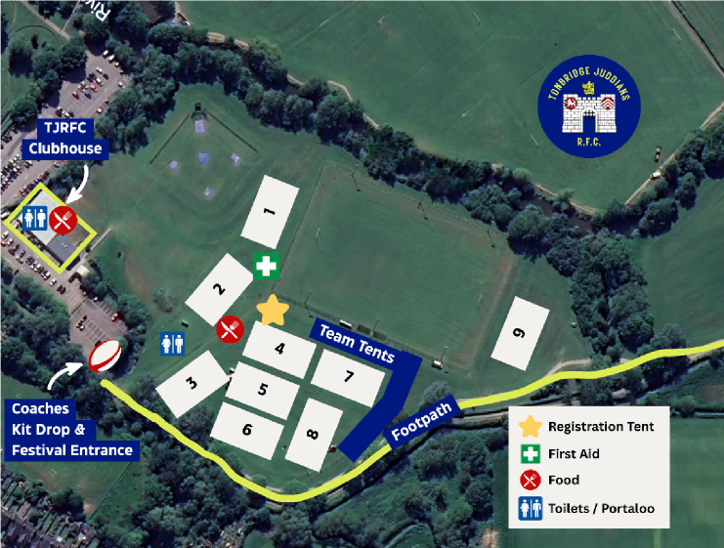

Club and Team name
(if more than 1 team entered please enter a sheet for each team)
Age Group
Head Coach name
Contact number
Referee
Team first aider name

 | Name of Player | Date of Birth | RFU Registration Number | Parent/ Guardian Consent to photography
1
2
3
4
5
6
7
8
9
10
11
12
By completing this team sheet, you agree to the festival terms and conditions, including:
- All players must be RFU affiliated and registered to their club.
- Each team must provide a referee and first aider.
- Any dispensations or out-of-age-band approvals must be declared in advance.

Kent County RFU contact list

Kent County RFU Minis Contact
Dawn Waters | 07931511424 | mini-rugby@kent-rugby.org
Jamie Callaway | 07753451021 | mini-rugby-vicechair@kent-rugby.org

Kent County RFU Safeguarding
Dawn Stanford | safeguarding@kent-rugby.org

Kent County RFU Disciplinary
Jayne Ashdown Denny | age-grade-discipline@kent-rugby.org

Kent County RFU Rugby Safe
Peter Thompson | rugbysafe@kent-rugby.org

